VERBOS ER

Comer – to eat
Aprender – to learn
Comprender – to understand
Barrer – to sweep
Beber – to drink
Correr – to run
Cometer – to commit
Creer – to believe
Deber – to owe/ought to
Esconder – to hide
Leer – to read
Perder – to lose
Prender – to turn on
Romper – to break
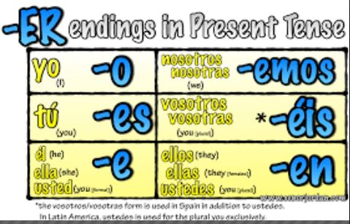
Sorprender – to surprise
Temer – to fear
Toser – to cough
Vender – to sell

