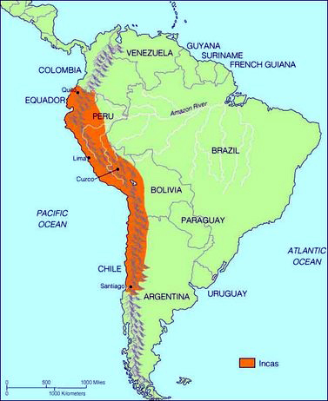

1. **What was the largest and most powerful native American group in South America before  
   the arrival of the Spanish?**

**The Incas. Their empire extended from Colombia along the coast of South America all the way to the South of Chile.**

1. **Who was the Spanish conquistador (conquerer) known for his exploits in South America?  
   Francisco Pizarro is credited for conquering the Incas and large parts of South America.**
2. **During Colonial times (Spanish rule) which city was the largest and most affluent in South America?   
   Lima which is now the capital of Peru was once a very important and beautiful city known as the “Pearl of the Pacific”.**
3. **Why is the Cañón del Pato such a dangerous road?  
   It stretches along a river between Huaraz and Trujillo, where there are often, landslides, dangerous road conditions, bandits, and accidents on the narrow road.**
4. **What are the symptoms of altitude sickness(el soroche)?  
   People get headaches, fatigue, nausea, bleeding (bloody noses and sometimes even aneurisms or bleeding in the brain.) Many people chew coca leaves or drink coca tea to relieve these symptoms.**
5. **What percentage of Peru does the Amazon jungle cover? 50%/half of the country**
6. **What are the Nazca lines and when were they made?  
   These lines were made in the desert by the Nazca people between 300 BC and 700 AD that depict animals, geometric shapes and an astronaut. They were believed to be an offering to please the gods.**
7. **What is the name of the sacred lake at 12,000 ft? What is unusual about the Uros people and where they live? Lake Titicaca. The Uros people have lived on floating islands made from Totoro reeds for more than 3000 years.**
8. **What was the capital of the Inca Empire? What happened to it when the Spanish arrived?  
   Cusco. When the Spanish came they destroyed the inca temples and buildings and built their city on top.**

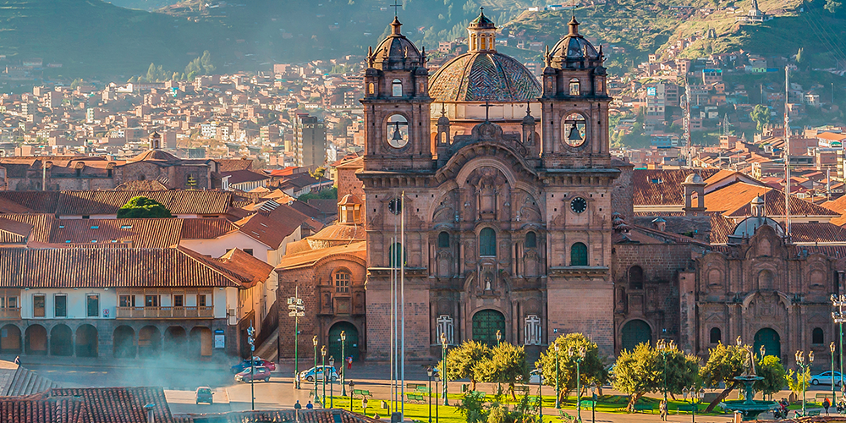

1. **What is the most important day in the Inca Calendar? How do they celebrate?  
   The winter solstice (June 21). There are parades and ceremonies to celebrate and they culminate with the sacrifice of a llama. They believe the intestines of the llama will provide information about the coming year.**
2. **What is Machu Picchu?  
   It is a holy city in the mountains built by the Inca king Pachacuti. The Spanish never found it.**



1. **How did the Incas communicate messages between distant cities? They had runners called Chaskis who ran 1.5 miles and then passed off their message to the next runner. These relays allowed messages to pass quickly from one end to the other of the Inca Empire.**



1. **What was the importance of the mountain behind  
   Machu Picchu? Who used this mountain?  
   Huayna Picchu was used for religious ceremonies. The Incas believed that their Apus (gods) were on the tops of the mountains. Only the King, important people, and priests were allowed up there.**
2. **What is the town of Aguas Calientes known for?  
   They have natural hot springs and it is a home base for many people travelling to Machu Picchu.**
3. **What is the unit of currency (money) in Peru?  
   The ‘sol’ or ‘soles’**

