Nombre________________
Grupo_________________
Fecha_________________

Study Guide for Seventh Grade Spanish Final (SLO exam)
There are a lot of questions on the test in Spanish. Make sure you know the question words and their meanings:
Qué – What
Cómo – How
Cuántos/as – How many
Cuál – Which/What
Quién(es) – Who/who(pl)
Por qué – Why
Cuándo – When
Dónde – Where

Make sure you know how to answer the oral questions that we have practiced in class:
¿Cómo estás?
¿Cómo te llamas?
¿Cúantos años tienes?
¿Cuántas personas hay en tu familia?
¿Cuántos hermanos tienes?
¿Dónde vives?
¿Hablas español?
¿Viajas/Cocinas/Caminas mucho con tu familia?
¿Qué te gusta hacer?

Review all the vocabulary for numbers and how to tell time:
Uno  Dos  Tres  Cuatro  Cinco  Seis  Siete  Ocho  Nueve  Diez | Once  Doce  Trece  Catorce  Quince  Dieciséis  Diecisiete  Dieciocho  Diecinueve  Veinte | Veintiuno  Veintidós  Veintitrés  Veinticuatro  Veinticinco  Veintiséis  Veintisiete  Veintiocho  Veintinueve  Treinta  Treinta y uno | Cuarenta  Cincuenta  Sesenta  Setenta  Ochenta  Noventa

Son las ______________ y _____________ de la mañana/tarde/noche
(hora) (minutos)
y cuarto (quarter past)
y media (half past)
¡Ojo! – Remember that if we are talking about one o’clock we must use: Es la una…

Know the vocabulary for school supplies and classroom materials:
(Practice with the quizlet on the website.)

Know the food vocabulary we talked about in class:
(Practice with the quizlet on the website.)

Review the pronouns. Know their meanings:
yo - I nosotros - we
tú – you (sing. Informal) vosotros – y’all (plural, informal)
él -he ellos - they
ella – she ellas – they (all girls)
usted – you (sing. Formal) ustedes – you (plural, formal)

Know how to conjugate the AR/ER verbs and review their meanings:
(Review with the quizlet on the website.)
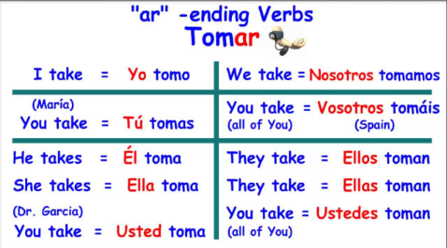
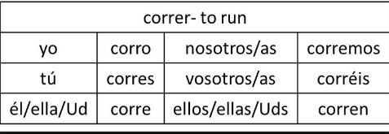

Know how to conjugate the irregular verb SER – to be
